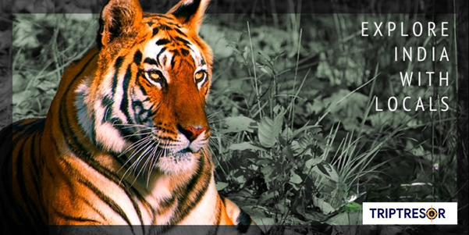
Flavors, Faces & the South
Circuit: Chennai – Kanchipuram – Mahabalipuram – Pondicherry – Tanjore – Rameshwaram – Kanyakumari – Madurai – Coimbatore – Ooty – Mysore – Bangalore
On this journey, we will explore the capital of India and the southern region, visiting cities that are famous for their rich culture, temples, forts, and monuments.
India is a vast and extraordinarily diverse country, with a cultural and historical heritage that dates back thousands of years. As the cradle of great civilizations and religions, it captivates visitors with its iconic monuments, royal palaces, ancient temples, and vibrant cities. Its colorful festivals, deep spirituality, and the warmth of its people create a truly unique experience. The incredible variety of landscapes—from deserts and jungles to mountains and coastlines—combined with its rich cuisine and ancient traditions, makes India a fascinating destination full of contrasts.
ITINERARY PUBLISHED:
(Subject to changes depending on circumstances)

DAY 01 | ARRIVAL – CHENNAI
Upon arrival at Chennai International Airport, meet and receive assistance before transferring to your hotel. Check in and relax after your journey.
Overnight stay in Chennai

DAY 02 | CHENNAI – KANCHIPURAM – MAHABALIPURAM (150 km / 4 hrs)
After breakfast, embark on a guided sightseeing tour of Chennai. Visit the Government Museum to admire the renowned bronze gallery showcasing exquisite Chola art. Drive through the vibrant flower and fruit markets, past the Indo-Saracenic High Court, and the Fort Museum housing colonial-era memorabilia. Continue to Marina Beach, one of the longest urban beaches in the world. Visit San Thome Cathedral, believed to enshrine the relics of St. Thomas the Apostle, Kapaleeshwara Temple, and the Snake Park.
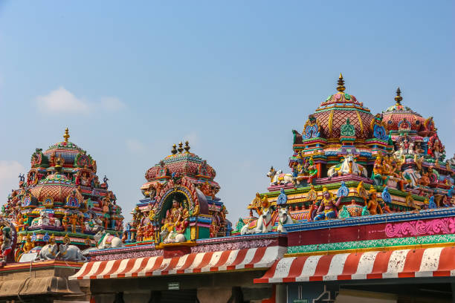
Later, drive towards Mahabalipuram, stopping en route at Kanchipuram, one of India’s seven sacred cities. Dating back to the early Chola period (2nd century), Kanchipuram was once home to over 1,000 temples, of which about 200 remain. Visit the 7th-century Kailasanatha Temple, the beautifully sculpted Varadaraja Temple with its 96-pillared hall, Ekambareswarar Temple, and Vaikuntha Perumal Temple. The town is also renowned for its fine silk weaving tradition.
Continue to Mahabalipuram. Upon arrival, check in at the hotel.
Overnight stay in Mahabalipuram

DAY 03 | MAHABALIPURAM – PONDICHERRY (95 km / 2 hrs)
After breakfast, proceed for sightseeing in Mahabalipuram, a UNESCO World Heritage Site. Explore its remarkable rock-cut and monolithic monuments, including cave temples, rathas, mandapams, and sculpted relief panels dating from the 7th–8th centuries. Highlights include the Shore Temple, Arjuna’s Penance, and the Five Rathas, depicting scenes from Hindu mythology and daily life.
Later, drive to Pondicherry. Check in upon arrival. In the afternoon, visit the Sri Aurobindo Ashram, founded in 1926 as a spiritual community blending yoga and modern thought. Also visit the Pondicherry Museum, showcasing archaeological artifacts and French colonial memorabilia, and the Sacred Heart Church, noted for its Gothic architecture and stained-glass windows.
Overnight stay in Pondicherry

DAY 04 | PONDICHERRY – TANJORE (173 km / 2 hrs)
After breakfast, drive to Tanjore and check in at your hotel. The remainder of the day is free for leisure or exploring the surroundings.
Overnight stay in Tanjore

DAY 05 | TANJORE
After breakfast, visit the iconic Brihadeeswara (Brahadeeswara) Temple, an 11th-century architectural marvel built entirely of granite. Admire its towering vimana crowned with a single 80-ton granite dome, an engineering feat achieved using a 6-kilometre ramp.
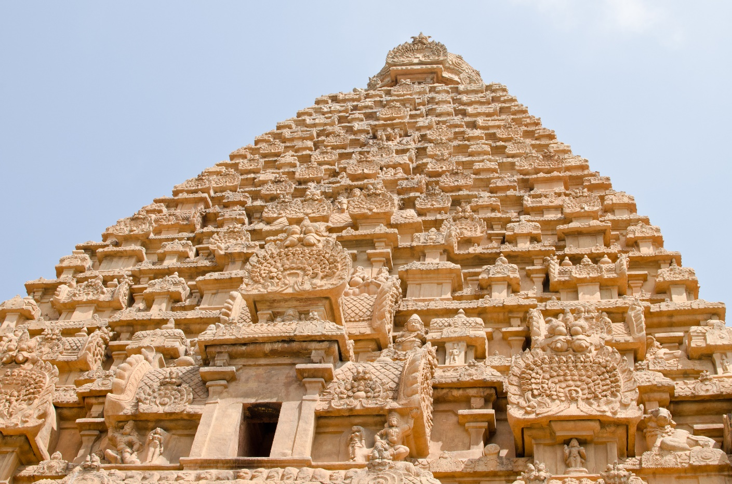
Overnight stay in Tanjore

DAY 06 | TANJORE – RAMESHWARAM (248 km / 04 hr)
After breakfast, drive to Rameshwaram and check in at the hotel.
Rest of the day free for relaxation / explore surrounding
Overnight stay in Rameshwaram

DAY 07 | RAMESHWARAM
After breakfast, proceed for a full-day sightseeing tour. Visit the sacred Ramanathaswamy Temple, one of the twelve Jyotirlinga shrines of Lord Shiva. Renowned for its magnificent gopurams, intricately carved pillars, longest temple corridors in India, and a towering Nandi statue, the temple is a masterpiece of Dravidian architecture and spiritual devotion.
Continue to Dhanushkodi Beach, located at the confluence of the Bay of Bengal and the Indian Ocean. Steeped in Ramayana legends, it is believed to be the site where Lord Rama initiated the construction of the bridge to Lanka. The pristine white sands, turquoise waters, and haunting ruins create a powerful and unforgettable atmosphere.
Visit Agni Theertham, the sacred seashore opposite the Ramanathaswamy Temple. According to legend, Lord Agni bathed here to absolve himself after testifying to Goddess Sita’s purity. A holy dip here is believed to cleanse sins and bestow spiritual merit.
Overnight stay in Rameshwaram

DAY 08 | RAMESHWARAM – KANYAKUMARI (308 km / 6 hrs)
After breakfast, drive to Kanyakumari, the southernmost tip of mainland India. Upon arrival, check in at the hotel. Located at the confluence of the Indian Ocean, Arabian Sea, and Bay of Bengal, Kanyakumari is a revered pilgrimage destination dedicated to Goddess Kanya Devi. Visit the Vivekananda Rock Memorial, built in honor of Swami Vivekananda. Kanyakumari is uniquely famous for witnessing both sunset and moonrise on full-moon evenings.
Overnight stay in Kanyakumari

DAY 09 | KANYAKUMARI – MADURAI (245 km / 4 hrs)
After breakfast, drive to Madurai and check in. In the afternoon, visit the magnificent Meenakshi Amman Temple, a jewel of Dravidian architecture adorned with towering gopurams covered in vibrant sculptures. Also visit the Tirumalai Nayak Palace, a 17th-century Indo-Saracenic structure renowned for its grand arches and decorative stucco work.
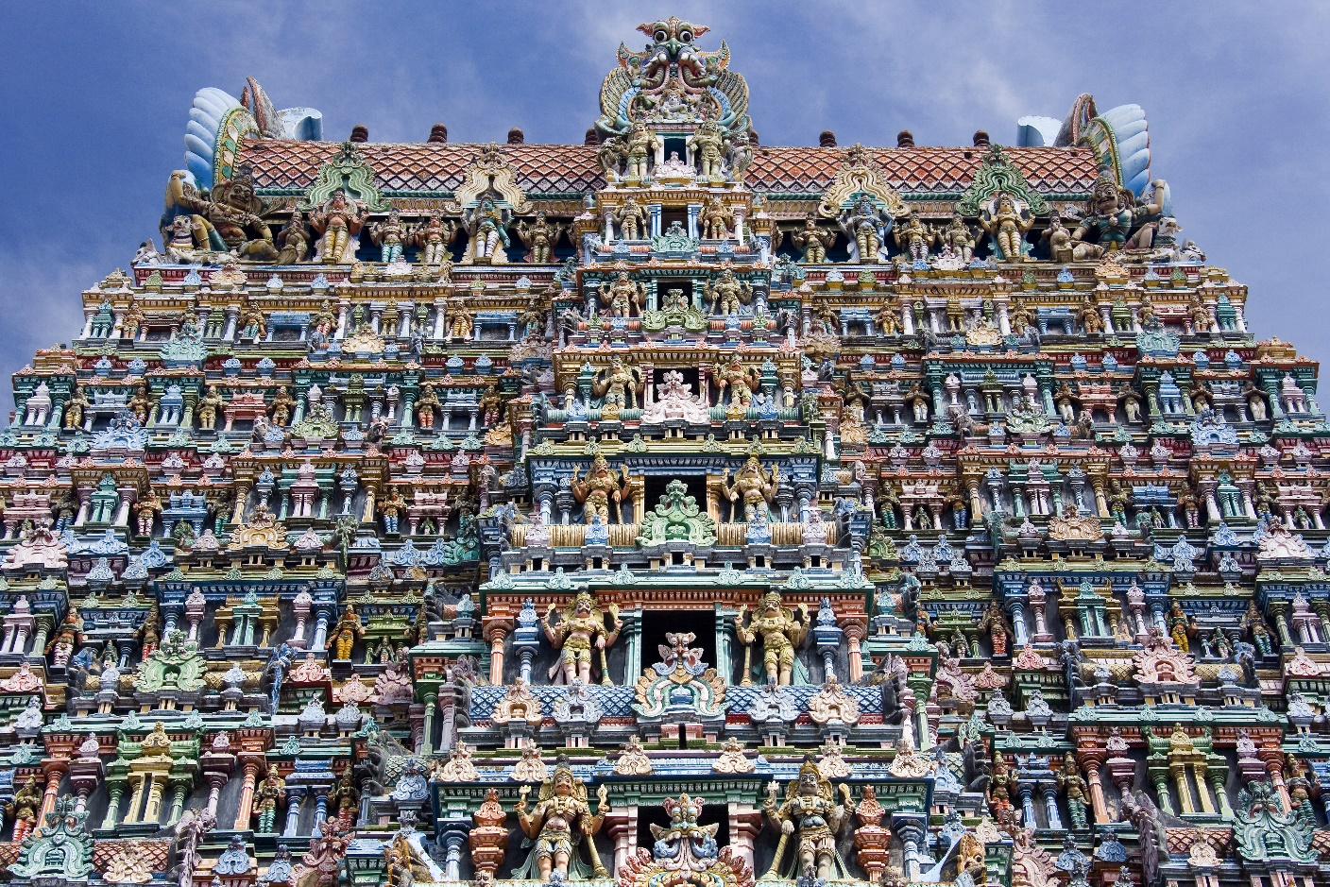
Overnight stay in Madurai

DAY 10 | MADURAI – COIMBATORE (217 km / 4 hrs)
After breakfast, drive to Coimbatore and check in at hotel in Coimbatore. In the afternoon, visit the Sri Svetambara Vimalanthar Jain Temple, dedicated to Lord Vimalanatha, known for its serene atmosphere and spiritual simplicity.
Continue to St. Michael Xavier Church in Big Bazaar, one of the city’s oldest churches, admired for its graceful architecture. Also visit the historic Athar Jamid Mosque on Oppalamara Street, an important Islamic landmark reflecting Coimbatore’s multicultural heritage.
Overnight stay in Coimbatore

DAY 11 | COIMBATORE – OOTY (87 km / 3 hrs)
After breakfast, drive to the scenic hill station of Ooty. Upon arrival, check in at the hotel. The rest of the day is free for leisure or exploring the surroundings.
Overnight stay in Ooty

DAY 12 | OOTY
After breakfast, enjoy a sightseeing tour of Ooty. Visit the Botanical Gardens established in 1848, home to over 1,000 plant species and a 200-million-year-old fossilized tree trunk. Visit Ooty Lake for boating and proceed to Doddabetta Peak, the highest point in the Nilgiri Hills, offering panoramic views.
Overnight stay in Ooty

DAY 13 | OOTY – MYSORE (269 km / 7 hrs)
After breakfast, drive to Mysore. Upon arrival, check in at the hotel. The rest of the day is free for relaxation or local exploration.
Overnight stay in Mysore

DAY 14 | MYSORE – BANGALORE (142 km / 2 hrs)
After breakfast, visit the grand Mysore Palace, built in 1911–12, a stunning blend of Hindu and Saracenic architectural styles. Visit the art gallery and proceed to Chamundi Hill to see the Chamundeshwari Temple and enjoy panoramic views of Mysore. En route, view the massive monolithic Nandi Bull statue carved in 1659.
Later, drive to Bangalore and check in at the hotel.
Overnight stay in Bangalore

DAY 15 | DEPARTURE – BANGALORE
After breakfast, check out and proceed for sightseeing in Bangalore. Visit Lal Bagh Botanical Garden, featuring ancient trees, lotus pools, and terraces. See the Peninsular Gneissic Complex, housing one of the world’s oldest rock formations. Visit Tipu Sultan’s Summer Palace, the Bull Temple, and drive past prominent government buildings.
Later, transfer to Bangalore International Airport for your onward journey.
“¡Gracias por elegir explorar INDIA con nosotros!”
Visitas incluidas según itinerario:
In Chennai
Government Museum (Chola Bronze Gallery) – Outstanding collection of Chola bronze art | Flower and fruit markets – Glimpse of vibrant local life |High Court – Indo-Saracenic architectural landmark |Fort Museum – Colonial-era memorabilia |Marina Beach – One of the longest urban beaches in the world |San Thome Cathedral – Believed to house the relics of St. Thomas the Apostle |Kapaleeshwara Temple – Prominent Dravidian-style Hindu temple |Snake Park – Conservation centre for reptiles
In Kanchipuram
Kailasanatha Temple – Oldest temple in the city (7th century) | Varadaraja Temple – Famous 96-pillared marriage hall with fine sculptures | Ekambareswarar Temple – One of the Pancha Bhoota Shiva temples | Vaikuntha Perumal Temple – Classic Chola-era architecture | Kanchipuram silk sarees – Renowned silk weaving tradition
In Mahabalipuram (UNESCO World Heritage Site)
Shore Temple – Iconic seaside temple | Arjuna’s Penance – Massive rock-cut bas-relief | Five Rathas – Monolithic rock temples |Rock-cut caves and mandapams – 7th–8th century Dravidian art |Mythological carvings and daily-life scenes
In Pondicherry
Sri Aurobindo Ashram – Spiritual and philosophical centre | Pondicherry Museum – Archaeological finds and French colonial heritage | Sacred Heart Church – Gothic architecture with stained-glass windows | French Quarter – Colonial streets and serene atmosphere

In Tanjore (Thanjavur)
Brihadeeswara Temple – 11th-century Chola masterpiece |Towering granite vimana |80-ton monolithic dome |
Advanced ancient engineering

In Rameshwaram
Ramanathaswamy Temple – One of the 12 Jyotirlinga shrines of Lord Shiva |Longest temple corridors in India |Magnificent gopurams and carved pillars |Dhanushkodi Beach – Confluence of the Bay of Bengal and the Indian Ocean |Arichal Munai – Site linked to the Ramayana |Agni Theertham – Sacred sea bathing spot for ritual purification

In Kanyakumari
Confluence of three seas – Indian Ocean, Arabian Sea, and Bay of Bengal |Kanya Devi Temple – Dedicated to the Virgin Goddess |Vivekananda Rock Memorial – Tribute to Swami Vivekananda |Unique sunset and moonrise on full-moon days

In Madurai
Meenakshi Amman Temple – Iconic Dravidian architectural marvel |Towering, vividly sculpted gopurams |Tirumalai Nayak Palace – 17th-century Indo-Saracenic palace | Grand arches and decorative stucco work

In Coimbatore
Sri Svetambara Vimalanthar Jain Temple – Peaceful spiritual centre |St. Michael Xavier Church – Historic Christian landmark |Athar Jamid Mosque – Important Islamic heritage site |Religious and cultural diversity

In Ooty
Botanical Gardens (est. 1848) – Over 1,000 plant species |200-million-year-old fossilised tree trunk |
Ooty Lake – Boating activities |Doddabetta Peak – Highest point in the Nilgiri Hills |Scenic hill landscapes and cool climate

In Mysore
Mysore Palace – Royal residence built in 1911–12 |Blend of Hindu and Saracenic architecture |Art gallery |Chamundi Hill – Chamundeshwari Temple |Monolithic Nandi Bull statue (1659)

In Bangalore
Lal Bagh Botanical Garden – Historic garden with tropical flora |Peninsular Gneissic Complex – One of the world’s oldest rock formations |Tipu Sultan’s Summer Palace |Bull Temple – Monolithic bull statue |Historic government buildings.

COST OF TOUR

CATEGORY | COST PER PERSON
Per person cost based on 03 star hotels | USD 1244 per person

Cost based on 3 Star hotels: Expected hotels:

CITY | HOTEL 5* | ROOM | NIGHTS | LINK
Chennai | Grand Cascade or similar | Standard Room | 01 | https://grandcascadehotels.com
Mahabalipuram | Nirvana Boutique or similar | Boutique Room | 01 | Nirvana
Pondicherry | Hotel Priso or similar | Deluxe Room | 01 | Hotel Priso
Tanjore | Abi’s Inn or similar | Silver Suite Room | 02 | Abi's Inn
Rameshwaram | Brindavan Elite or similar | Deluxe Room | 02 | Brindavan Elite
Kanyakumari | Viswa Grand or similar | Executive Room | 01 | Viswa Grand
Madurai | Rio Grande Residency | Standard Room | 01 | Rio Grande
Coimbatore | Alankar Grand or similar | Standard Room | 01 | https://alankar.co.in
Ooty | Majestic Crown or similar | Standard Room | 02 | https://themajesticcrown.com
Mysore | Heritage Inn or similar | Standard Room | 01 | https://heritagein.in
Bangalore | Clarks Inn or similar | Deluxe Room | 01 | Clarks Inn
 | Total number of nights |  | 16 Nights

INCLUSIONS:
- Accommodation in hotels as per itinerary
- Daily breakfast at hotels
- All airport transfers (Chennai arrival / Bangalore departure)
- Air-conditioned vehicle for all transfers and sightseeing
- Sightseeing as per itinerary
- Local English-speaking guide during sightseeing
- Entrance fees to monuments mentioned in the itinerary
- All applicable hotel and government taxes

EXCLUSIONS / NON-INCLUSIONS
- International & domestic airfares
- Entry visa (apply online: www.indianvisaonline.gov.in)
- Travel & cancellation insurance (optional)
- Tips to guides, drivers & hotel staff
- Lunches, dinners & beverages
- Camera/video fees at monuments
- Personal expenses (laundry, phone calls, minibar, etc.)
- Any services not specifically mentioned in inclusion

